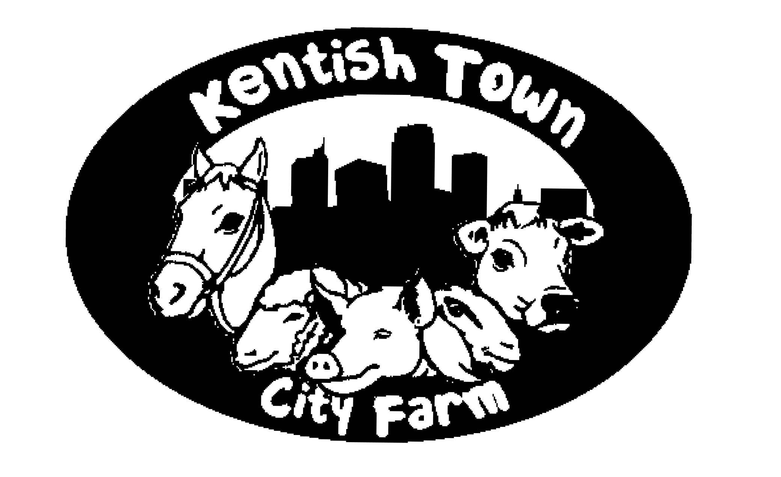

POLICY STATEMENT - COVID LOCKDOWN
4th NOVEMBER 2020

We are an essential resource for many of our users. The charity exists to ‘improve the conditions of life’ for the people of Gospel Oak and surrounding areas..
The Kentish Town City Farm is in an area of high population density, providing a safe green space for our community. It’s important that the space remains available for those who need it most. We have run outdoor activities safely and without incident since August. As people have returned to the farm many of them have talked about how isolated lockdown left them. Our local green spaces were overrun with people exercising and people’s lives have lacked purpose without the farm. We know now that we are a vital resource for these groups and individuals.
We aim to provide support to our community within the guidance. As stated ‘You can exercise or visit outdoor public places with the people you live with, your support bubble, or 1 person from another household (children under school age, as well as those dependent on round-the-clock care, such as those with severe disabilities, who are with their parents will not count towards the limit on two people meeting outside). There is additional specific guidance for ‘childcare and children’s activities’, which states that ‘playgrounds can remain open’ as well as ‘Some venues will be allowed to remain open for specific exempt activities, like childcare and support groups. Support groups that are essential to deliver in person can continue with up to 15 participants where formally organised to provide mutual aid, therapy or any other form of support. This includes […] new parents and guardians, people with long-term illnesses, and those who have suffered bereavement.
As a charity we are not a business and have not positioned ourselves as a venue or visitor attraction. Our offer is very locally focused, providing an essential service for families (respite and mutual support). We do have animals on site, but also a huge community garden, natural habitats and lots of opportunity for train spotting. Our work has historically focused on the social and therapeutic benefits of these activities and are not commercially driven.

We will remain open on a limited scale with the following measures

- Limited capacity (1 household or support bubble, max 6 people on site at any one time)
- No indoor activities
- Data collection via booking system for track and trace.
- Three hot water handwashing stations across the site.
- Revised cleaning regime including increased cleaning of toilets.

We continue to respond to guidance as it is released. Many of our activities are educational, or provide essential support to people. We are reviewing all our policies and procedures and with staff and other stakeholders will make decisions within the framework laid out by the government.

Booking for private visits is now open via our website. Our capacity is massively reduced so priority is for individuals or groups who would not otherwise access green space. If this is you, please book via the website or email us info@ktcityfarm.org.uk

Please look after yourselves, each other and the natural world. if you need access to the farm get in touch with us. We look forward to welcoming you and your household/ support bubble.

